- Use ChatGPT to generate a detailed outline for a blog post about "Best Street Food Spots in Ahmedabad". Copy the outline into a document for reference.

1. Introduction
- Brief introduction to Ahmedabad’s street-food culture.
- Why Ahmedabad is famous for vegetarian Gujarati and street food.
- What readers will discover in the article.
- Mention popular areas such as Manek Chowk, Law Garden, and Bhathiyar Gali.

2. Manek Chowk – The Night Food Market
- Overview of Manek Chowk.
- Popular foods to try:
  - Cheese Sandwich
  - Pav Bhaji
  - Chocolate Sandwich
  - Gujarati snacks
- Best time to visit.
- Tips for first-time visitors.

3. Law Garden Night Market
- Introduction to the food and shopping atmosphere.
- Popular street foods.
- Best snacks and drinks to try.
- Approximate budget.

4. Bhathiyar Gali
- Introduction to the famous food street.
- Popular dishes and local specialties.
- Why it is popular among food lovers.
- Best time to visit.

5. Foodie’s Paradise at CG Road
- Popular food stalls and quick bites.
- Recommended snacks.
- Suitable options for evening food trips.

6. Best Gujarati Street Foods to Try in Ahmedabad
- Fafda-Jalebi
- Khaman
- Dhokla
- Locho
- Khakhra
- Sev Khamani
- Gujarati-style sandwiches

7. Best Places for Evening Street Food
- Manek Chowk
- Law Garden
- Bhathiyar Gali
- Other popular food areas
- What makes each location different.

8. Budget Guide
Create a simple comparison:
- Budget-friendly options
- Mid-range street-food experience
- Approximate cost per person.

9. Tips for Exploring Ahmedabad Street Food
- Visit during suitable hours.
- Carry cash/UPI.
- Check hygiene before eating.
- Try smaller portions when visiting multiple stalls.
- Respect local food customs.

10. Frequently Asked Questions (FAQs)
- What is the most famous street food in Ahmedabad?
- Which is the best street food market in Ahmedabad?
- What food is Ahmedabad famous for?
- Where can I find the best Gujarati snacks?
- Is Ahmedabad street food vegetarian?

11. Conclusion
- Summarize the best food spots.
- Encourage readers to explore Ahmedabad’s street-food culture.
- Include a call-to-action such as: “Save this guide for your next Ahmedabad food tour!”
- Pick any AI content writing tool (such as Jasper, Writesonic, or Copy.ai) and use it to write a 200-word introduction for a blog post about "How to Save Money on Online Shopping".

Tool Used: Writesonic

Topic: How to Save Money on Online Shopping

Introduction (~200 words)
Online shopping has become a convenient part of everyday life. With just a few clicks, you can compare products, read reviews, and have your purchases delivered directly to your doorstep. However, the convenience of online shopping can also make it easy to overspend. Flash sales, limited-time offers, free shipping deals, and personalized recommendations can encourage shoppers to buy things they may not actually need.
The good news is that you don't have to stop shopping online to save money. With a few smart strategies, you can find better deals and make more informed purchasing decisions. Comparing prices across different websites, using discount coupons, applying cashback offers, and waiting for major sale events can significantly reduce your expenses. You can also create a shopping budget, avoid impulse purchases, and check whether a product is genuinely worth its price before placing an order.
In this blog, we will explore practical ways to save money on online shopping without compromising on the products you need. Whether you shop occasionally or regularly, these simple tips can help you become a smarter shopper, avoid unnecessary expenses, and keep more money in your wallet.
- Check the content you generated in the previous task for plagiarism using a free online plagiarism checker like SmallSEOTools or Quetext, and take a screenshot of the result.
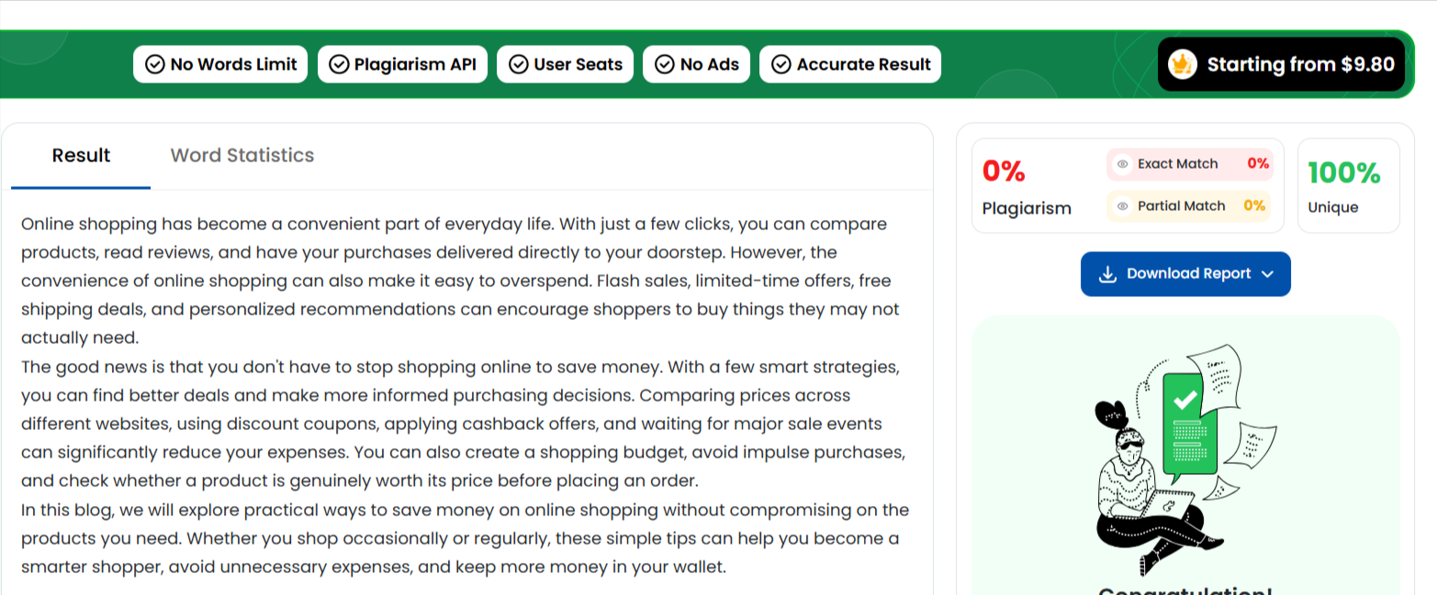

Edit your AI-generated blog introduction to make it sound more human and less robotic—change at least 5 sentences to add your personal touch, local references, or a conversational style.<br><br><em><strong>Hint:</strong> Try using phrases or examples from your own online shopping experience.</em>
How to Save Money on Online Shopping
Let’s be honest—online shopping can be a little addictive. I often open Amazon, Flipkart, or Myntra just to check one product and somehow end up adding three more things to my cart. Those attractive “50% OFF” banners and limited-time deals can make it really difficult to decide whether I actually need something or simply want it.
Living in Ahmedabad, I also find online shopping convenient when I want to avoid traffic, especially during busy days or when I need something delivered quickly. But convenience doesn’t always mean saving money. Sometimes a product may look cheaper until delivery charges, taxes, or other costs are added at checkout.
Over time, I’ve started using a few simple tricks to control my spending. I compare the same product on different websites, check coupon codes, look for bank offers, and read customer reviews before buying. I also put items in my cart and wait for a day or two instead of purchasing them immediately.
In this blog, I’ll share practical ways to save money on online shopping without giving up the convenience we all enjoy. From finding genuine discounts to avoiding impulse purchases, these simple tips can help you shop smarter and keep more money in your wallet.

